Question 7:
Make a dictionary of fruit names with their prices. Add a new fruit and print everything.
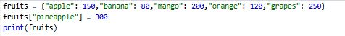
Output:

